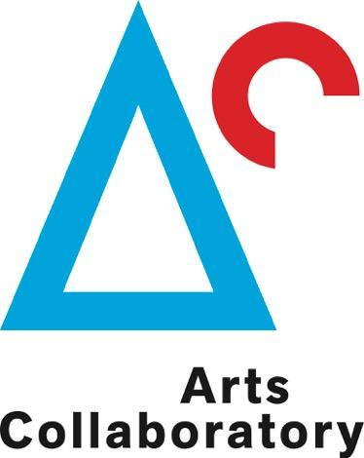

Application: Residency opportunity in Colombia for artists, curators, or researchers, related to Arts Collaboratory participants

Deadline for summary proposal
31st July 2017

I. APPLICANT

ARTSCOLLABORATORY
Mail your application form to:
call@artscollaboratory.org

This form is your application to Arts Collaboratory. Please keep it short and to the point, we ask you to limit your answers to a maximum of six A4 pages.

1. Basic info.

Name and Surname:
Date of birth:
Correspondence address:
Postcode:
Country of residency:
Telephone number:
Email address:
Website: (if applicable)
I wish to apply for the residency with:
(see http://artscollaboratory.org/participants/ )
note: you can apply up to 2 organizations in Colombia
Proposed period of stay:
note: 6-8 week residencies to take place between 1st February and 30th June 2018
How did you hear about this residency call?

II. THE RESIDENCY

1. Motivation Statement (up to 1000 words)
Describe the motivation/background for your stay at the specific residency. Describe the specific project you wish to develop or the starting points/ideas for working at the residency

2. What will you need from the organization(s) to achieve this? (up to 200 words)
Local arts scene, wider communities, locations, translation, assistant, materials, etc.

3. Describe your tentative list of activities before, during and after your residency (up to 300 words).
Previous research and contacts, project execution, presentation and knowledge sharing in the home country

4. Links of previous works

5. Portfolio (15 images maximum) and C.V.
Please attach this documents in PDF files up to 10 megas send it to call@artscollaboratory.org with the subject “Residency proposal”)

6. Other
Do you have any other additional remarks?

