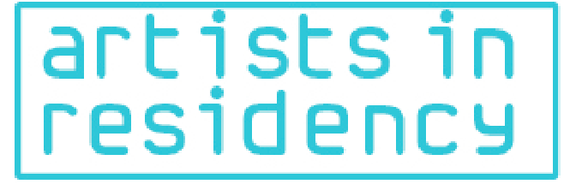

ARTISTS IN RESIDENCY (AIR) 2015 – APPLICATION FORM
APPLICATION DEADLINE: 30 September 2015

1. RESIDENCY APPLYING FOR:
Please indicate which Artists in Residency programme/s you are applying for.
You are permitted to apply for as many of the residencies as you wish.

Bundanon Trust – Australia
The Fountainhead Residency – USA
Jiwar Creation & Society – Spain
Khoj- India
Kuona Trust – Kenya
Nafasi Arts Space – Tanzania
Rockefeller Foundation Bellagio Center – Italy
Sacatar – Brazil

Please carefully read through the Application Guide for more details about each Residency and ensure that the Residency you are applying for caters to your artistic discipline.

2. APPLICANT DETAILS:

Full Name (as it appears on your Passport/ID):
Place of Birth:
Birth Date:
Street Address:
City:
Country You Currently Reside In:
Landline Number:
Mobile Number:
E-mail address:
Which language/s do you speak:

3. WHAT IS YOUR PRIMARY MEANS OF ARTISTIC EXPRESSION

Visual Arts
Performing Arts
Literature/ Creative Writing
Music
Film
Other ……………………………………………Please specify

4. WHY HAVE DECIDED TO BE AN ARTIST? WHAT HAS LED YOU TO YOUR CREATIVE PATH? [100 words maximum]

5. WHY DO YOU WANT TO PARTICIPATE IN THE ARTIST IN RESIDENCY PROGRAMMES OFFERED.
[ 100 words maximum]

6. WHY IS YOUR ART IMPORTANT?
[100 words maximum]

7. HOW DOES YOUR ART MAKE A SOCIAL CONTRIBUTION, OR WHAT KIND OF CONTRIBUTION CAN YOUR ART MAKE?
[100 words maximum]

8. WHAT ARE YOUR OVERALL GOALS FOR YOUR RESIDENCY?
[100 words maximum]

9. WHAT ARE YOU INTERESTED IN WORKING ON WHILE PARTICIPATING IN YOUR PREFERRED RESIDENCY PROGRAMME AND WHY? WHAT OUTPUT/PRODUCTS DO YOU ANTICIPATE WILL RESULT FROM YOUR RESIDENCY? [500 words maximum]

10. IF ANY, WHAT KIND OF COLLABORATION DOES YOUR IDEA ENTAIL? [100 words maximum]

11. IF YOU WERE SELECTED FOR A RESIDENCY, HOW WOULD YOU DETERMINE OR MEASURE ITS SUCCESS AFTER COMPLETION? [100 words maximum]

12. WHAT ARE YOUR EXPECTATIONS OF YOUR PREFERRED RESIDENCY? [100 words maximum]

13. HOW DID YOU FIND OUT ABOUT THE AIR 2015 PROGRAMME?

From a friend
Website: Please indicate which site
E-mail: Please indicate which organisation mailed you the information

By invitation: Please indicate from whom you received an invitation
On a notice board: Please indicate where you saw the notice

14. SUPPORTING DOCUMENTS

All applicants are required to accompany their application with the following supporting documents:
- Artist Statement/Biography: Describe your current projects and artistic process) [500 words maximum];
- Professional CV :Include career highlights i.e awards received,past residencies, a list of references and their contact details [3 pages maximum]; and
- Portfolio of Work / Web Link where your work can be viewed.

AIR is a project of the Africa Centre.

5th Floor, The Exchange Building, 28 St. George’s Mall, Cape Town, 8001, South Africa | tel: +27 21 418 3336 | airsubmissions@africacentre.net

Images –10 digital images should be submitted. Format still images as JPEGs with a width dimension no greater than 2400 pixels. Please include the title, size, medium and date of each work. Videos can be submitted using https://www.wetransfer.com or uploaded onto a video channel (i.e. youtube/vimeo) and a link shared. Please limit video clips or excerpts to no more than 5 minutes (indicate length of full video) and submit no more than 3 in total. Acceptable file formats include .mpg, .avi, .mov. Please test your video files to make sure they play on a Mac and PC. Writing samples of work published within the last five years where you are the primary author ( no more than 1,500 words per sample) should be submitted. Writers are asked to submit a maximum of 3 writing samples

